Ideation Phase
Brainstorm & Idea Prioritization Template

Date | 25 June 2026
Team ID | Not Given
Project Name | Rising Waters
Maximum Marks | 4 Marks

Team Members | Skill Wallet Team ID’s | Roll Numbers (College: ACET)
Mohana Deepika Kancherla (Team Leader) | SWUID2026226898 | 23MH1A0596
Flora Disowja Sarugolu | SWUID2026212008 | 24P35A0549
Santhi Illa | SWUID2026212021 | 24P35A0550
Mathan Bhavesh Hari Raghava Krishna Munaga | SWUID2026212007 | 24P35A0532

Brainstorm & Idea Prioritization Template:
During brainstorming, several disaster management ideas were evaluated based on feasibility, impact, accuracy, scalability, and implementation complexity. A machine learning-based flood prediction system was prioritized because it addresses a critical real-world problem, provides timely flood risk predictions using weather data, supports disaster preparedness, and can be easily deployed through a Flask web application for practical use.
Step-1: Team Gathering, Collaboration and Select the Problem Statement
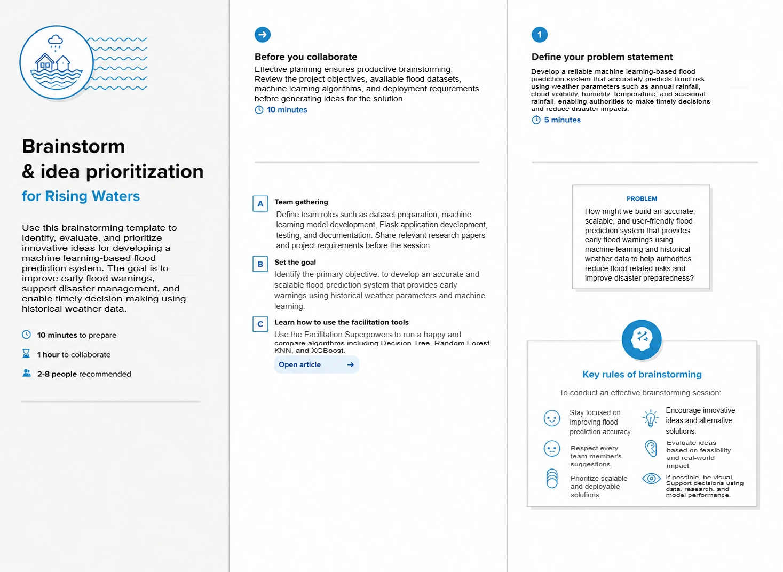
Step-2: Brainstorm, Idea Listing and Grouping
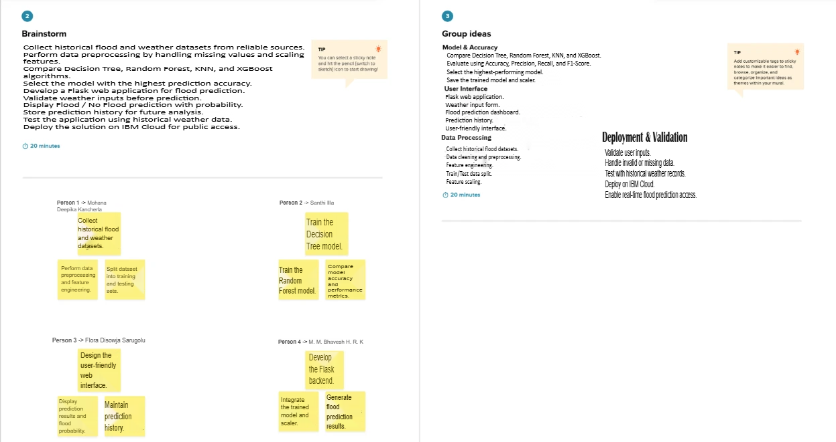
\Step-3: Idea Prioritization
